**Inventory Test – SYD366**

Name: Amirhossein Sabagh

Email: [asabagh@myseneca.ca](mailto:asabagh@myseneca.ca)

Seneca ID: 152956199

Date: 2020-11-06

**Question 1**

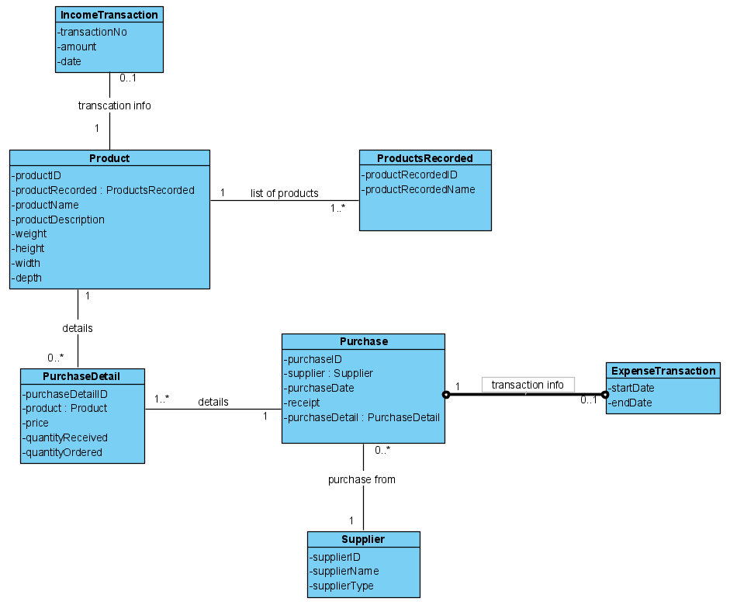

**Question 2**

|  |  |  |  |
| --- | --- | --- | --- |
| Use Case Name | Create Product Information | | |
| Triggering Event | A new product of interest to the business | | |
| Brief Description | Allows the Owner to record a new product. | | |
| Actors | Owner | | |
| Related Use Cases |  | | |
| Preconditions | Owner has opened the Main Menu. | | |
| Post Conditions | Product is saved to the database and now can be purchased or used in a service. | | |
| Flow of activities | Actor | | System |
|  |  | Requests to add a new product | Displays a list of products currently recorded in the system and prompts to add a new product. |
|  |  | Enters the product name, description, weight, height, width, and depth of the new product. | Verifies that all the data is entered. Displays the newly created product and requests to save. |
|  |  | Request to save | Saves the product and returns to the main menu |
| Exception Conditions | * Owner chooses to cancel adding the product | | |

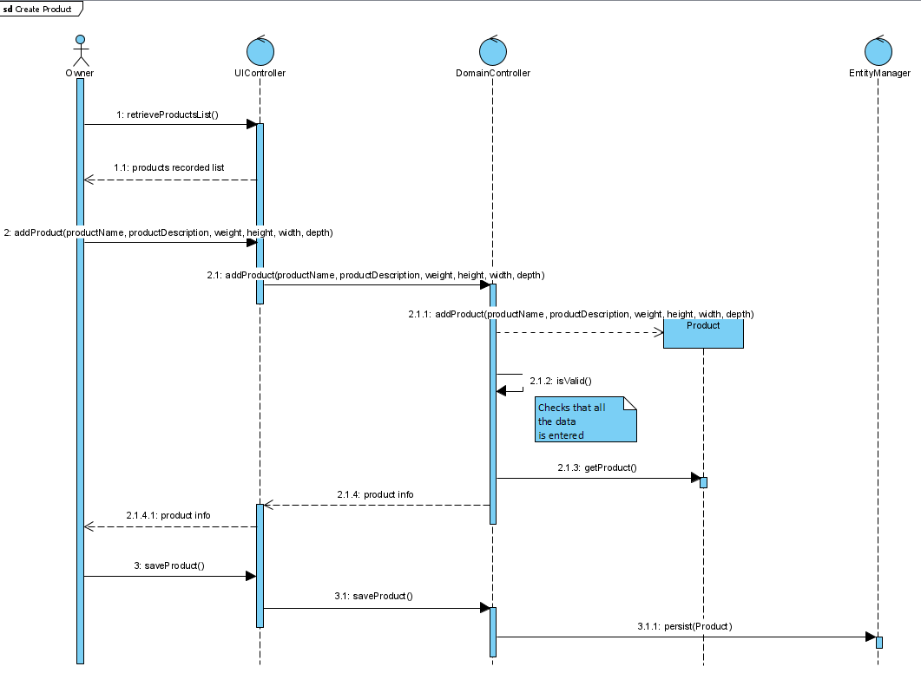**Create Product:**

**Retrieve Products Currently Recorded List**

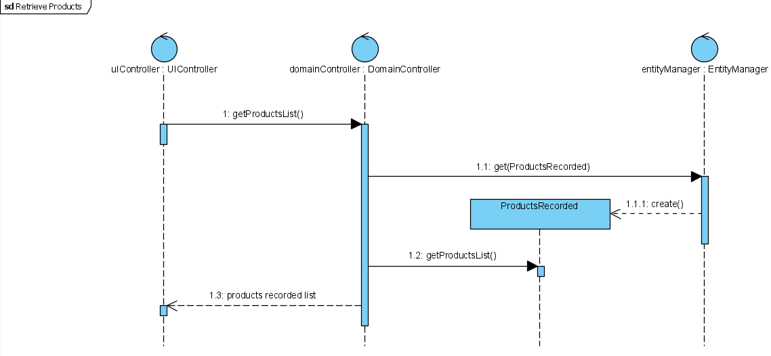

|  |  |  |  |
| --- | --- | --- | --- |
| Use Case Name | Create Purchase | | |
| Triggering Event | Purchase of a product. | | |
| Brief Description | Allows the Owner to record a new purchase. | | |
| Actors | Owner | | |
| Related Use Cases |  | | |
| Preconditions | Owner has opened the Main Menu. | | |
| Post Conditions | Purchase is saved to the database and now can be queried. | | |
| Flow of activities | Actor | | System |
|  | 1. | Requests to add a new purchase | Displays a list of suppliers and prompts for selection. |
|  | 2. | Selects a supplier. | Verifies that a supplier was selected. Prompts for purchase date and selection of receipt file location. |
|  | 3. | Enters purchase date and receipt file selected. | Verifies that date was entered, and receipt selected.  Creates a unique identifier for the purchase. Prompts to enter product details. |
|  | loop | Chooses new detail | Displays a list of products and prompts for selection. Prompts for price, quantity ordered, and quantity received |
|  | 4. | Selects a product and enters price and quantity. | Product must be selected.  Price and quantity must be entered  Weight of the purchase is calculated.  Displays purchase including weight, date and list of products.  Prompts to add another product |
|  | End | When all products selected | Displays purchase including weight, date and list of products.  Verifies that at least one product has been selected.  Prompts to save purchase |
|  | 5. | Chooses to save | Saves the purchase and returns to the main menu |
| Exception Conditions | * Owner chooses to cancel adding the purchase | | |

**Create Purchase:**

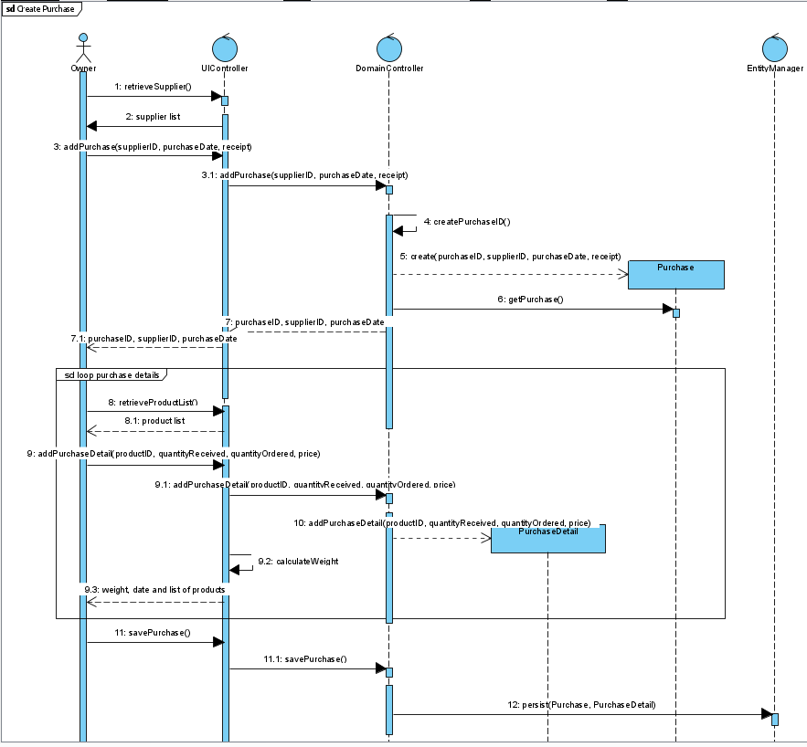

**Retrieve Supplier:**

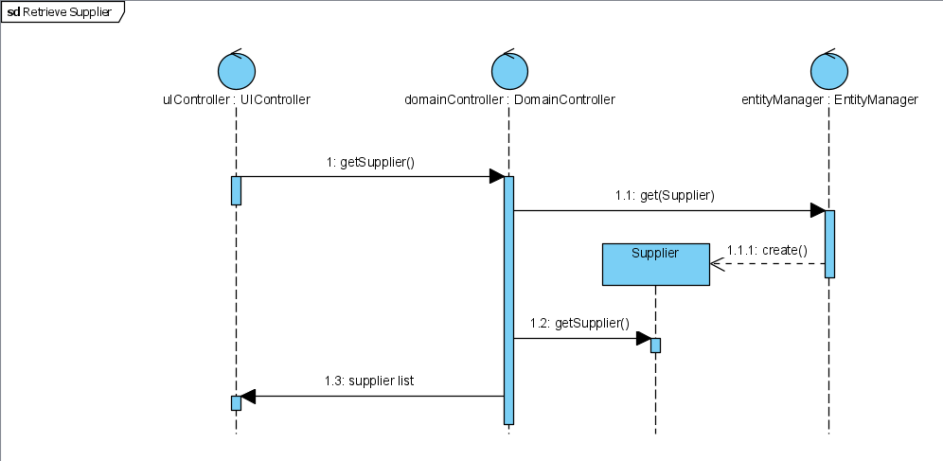

**Retrieve List of Products**



**Question 3**

I would declare a description class called "ProductsInventory" and associate it to the Products class. This way, Margaret would know where each item is located in the warehouse. To ease locating the products, the ProductsInventory description class will include attributes like rackNo, rackHeight, and productID : Products.

**Question 4**

The label printer is not an inventory as it is a tool that Margaret's company bought to control inventories with, it is not a product that they sell to their customers. So, no, it is not an inventory. an items is considered an inventory if fallen under one of these three categories: Raw Materials, Work-in-Progress, or Finished Goods

**Question 5**

Stock-keeping-unit (SKU) is a unique identification code number, specified for each of the company's items, to indicate the product's attributes like weight, height, width, and depth; they are used for sales and inventory tracking. It is crucial for Margaret to have SKUs assigned to her products as it helps her deal with the next question's problem, managing fulfillment. It also helps her when receiving shipments from her suppliers; if the products have SKUs, it is way easier for Margaret and her staff to check-in the items. Without, there's a high chance of data entry error and it possibly ends up in shrinkage of inventories.

**Question 6**

Margaret can use our model and use some of the attributes in the "Reorder Point Formula" and some other formulas to determine when is the best time to buy and how much items to buy. She can extract data regarding costs of goods sold (COGS) and the amount of money the whole process of preparing the inventory for selling is going to take and adapt the formula to examine the exact number of products needed to buy in order to fulfil their customers' needs and also fill the safety stock.

**Question 7**

The need for Reorder Point Formula shows itself in dealing with this question; this formula helps the Margaret to reorder her stock at the right time. The formula is simple: lead time demand plus safety stock. Lead time demand can be calculated by multiplying the lead time( days that it takes for a purchase to arrive from the supplier) to the average number of units of an item she sells per day. The next step is to add this number to the safety stock number (additional inventory that Margaret has to prevent shortage of a product).

We can modify our model and add these calculations to it, so the next time, Margaret could easily enter a product name, and we would retrieve the data mentioned and calculate the time that she needs to refill for her.